[***http://docs.oracle.com/javase/tutorial/uiswing/components/dialog.htm***](http://docs.oracle.com/javase/tutorial/uiswing/components/dialog.htm)***l***

***import javax.swing.JOptionPane;***

TITLE

TITLE BAR

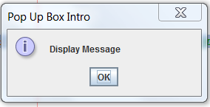

JOptionPane.*INFORMATION_MESSAGE*

Press OK Button or X to exit.

MESSAGE

JOptionPane.showMessageDialog(null, "Display Message", "Pop Up Box Intro ", JOptionPane.*INFORMATION_MESSAGE*);

MESSAGE

TITLE BAR

TITLE

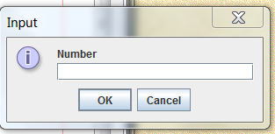

JOptionPane.*INFORMATION_MESSAGE*

Press OK to Accept Input and dismiss dialog

String sample = JOptionPane.showInputDialog(null, "Number", “Input" ,

JOptionPane.*INFORMATION_MESSAGE*);

**null-**

String-

System.exit(0);

Parsing Method-

int anynumber = Integer.parseInt(sample);

double anynumber = Double.parseDouble(inputString);

More Advanced GUI Implementation in NetBeans

https://www.youtube.com/watch?v=LFr06ZKIpSM

JFrame

AWT